eCertification -

Student Portal

Contents
1. Introduction 3
2. Functionality of the Student Portal 3
3. Website URL 3
4. Useful links 3
5. Registration 3
6. Login 4
7. Forgotten password 4
8. Dashboard 4
9. Connections – Share Documents with Others 5
10. Logout 6

Introduction
This guide describes user functions for the Student Portal of the eCertification software application supplied by Advanced Secure Technologies (AST).

Functionality of the Student Portal
Students can view electronic versions of qualification certificates in PDF image format.
Share electronic certificates with third parties by creating connections.
Keep personal details up to date by managing your profile.
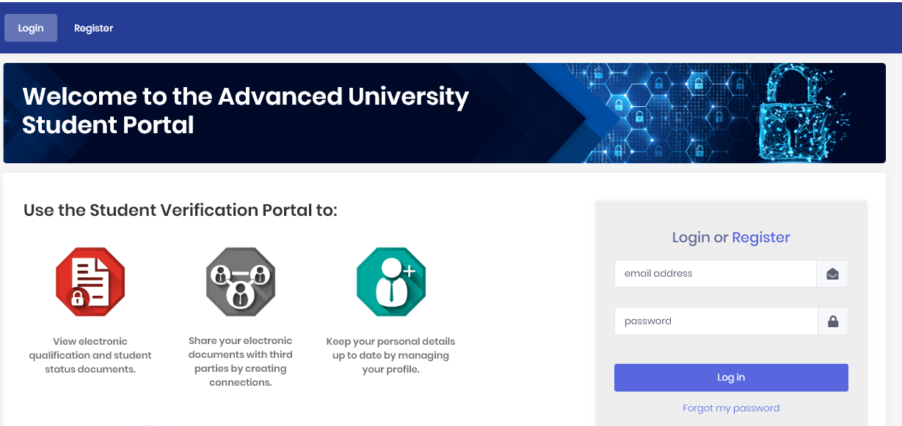

Website URL
The exact URL of the Student portal will be made available to you by the University. It will normally consist of https://student.univeristyname.ac.uk or similar.

Useful links
On the home page there are a number of useful links including About, Privacy, FAQ, Cookies, Terms and Support, should you require assistance, on the bottom right of the homepage.
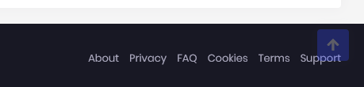

Registration
- Students are able to securely register onto the website using information which known by both Student and University.

This will consist of the student providing information during the registration process which is checked against existing data held in Digital Certificates. This will normally be Student ID, date of birth, first name and last name. There may also be additional items of information required. If the student does not provide exact matching data then the system will put the registration in a Pending authorisation queue which will need to be manually checked by a Website administrator, who will either accept or deny the registration. Correct entry of the required data will automatically register the student on completion of an email verification process.

Login
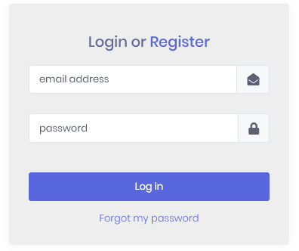
- Username – this is your email address.
- Email address – This can be changed from within your profile.
- Password – This can be changed from within your profile.
- Locked out – If you become locked out you can either wait until the system automatically unlocks you (this is configurable and varies between universities) or contact support using the details provided in the link.

Forgotten password
In the event that you have forgotten your password you will be able to recover from this by using the Forgotten Password procedure.

Dashboard
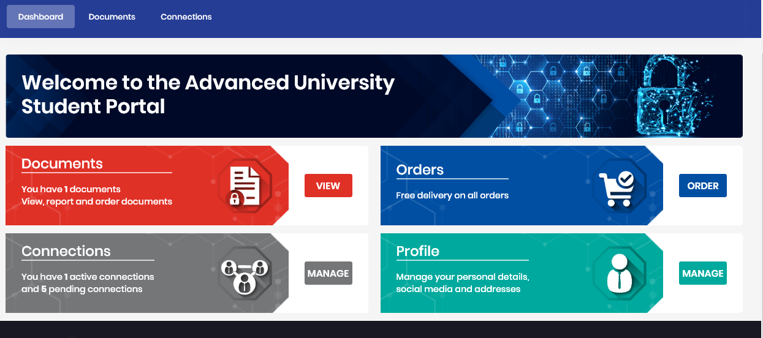
- Documents
  - Representations of Certificates are viewable in PDF image format.
  - You will notice when you view a document that there is a barcode present on the bottom right of the page. This can be scanned using an app on your mobile phone which will take you to the Certificate verification website. Here your document will verified as to whether or not it is an actual qualification issued by the University.
  - An issue report can be raised by the student for any enquiries regarding their document.
- Connections

  - Allows students to invite 3rd parties to have access to their secure documents online. Which documents are made available and for how long, are controlled by the student who may also end the connection at any time.

- Profile

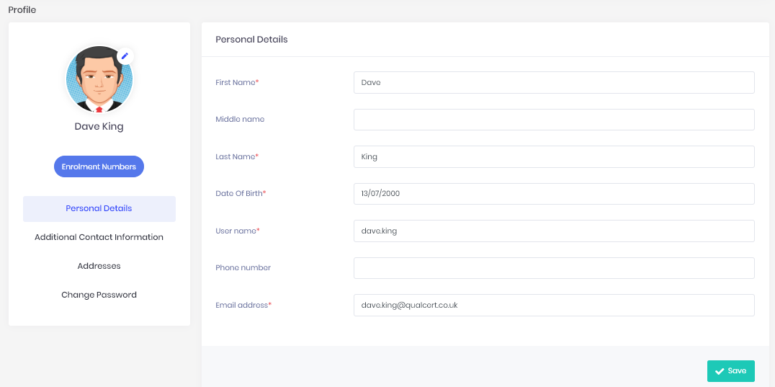
  - Photo
    - Click to browse to an image to change your profile photo.
  - Enrolment Numbers
    - Hover over to see your enrolment number/s
  - Personal details
    - Star indicates mandatory data
    - Edit as appropriate
    - Remember to Save any changes.
  - Additional Contact information includes
    - Phone numbers
    - Email addresses
    - Social media
  - Addresses
    - Store multiple addresses.
  - Change password here.

Connections – Share Documents with Others
Electronic documents on the Student Portal are only valid and secure when shared via the portal. To do so, click the “Manage” button on the Connections tile:
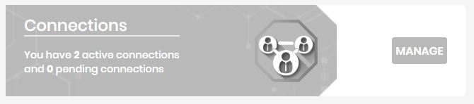
This shows a list of connections that you have made with others to share your documents:

Create a new connection here. The person you connect with will be sent an email to let them know.

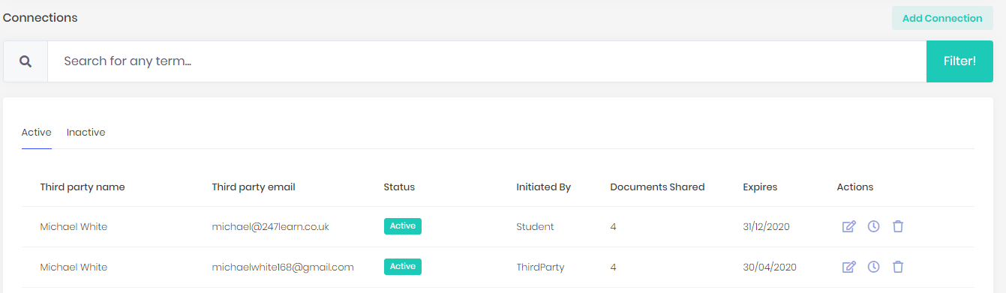
You can decide which documents you want to share:
You can also set an expiry date, so that the other person can only see the documents for a limited time.

Logout
A logout button can be found by clicking on your name or profile photo (Your Initials, if no photo is uploaded) at the top right of the web page.
