University eCertification -

3rd Party Portal

Contents
1. Introduction 3
2. Functionality of the 3rd Party Portal 3
3. Useful links 3
4. Registration 3
5. Login 4
6. Forgotten password 4
7. Dashboard 4
8. Profiles 5
9. Logout 5

Introduction
This guide describes user functions for the 3rd Party Portal of the University eCertification software application supplied by Advanced Secure Technologies (AST).

2. Functionality of the 3rd Party Portal
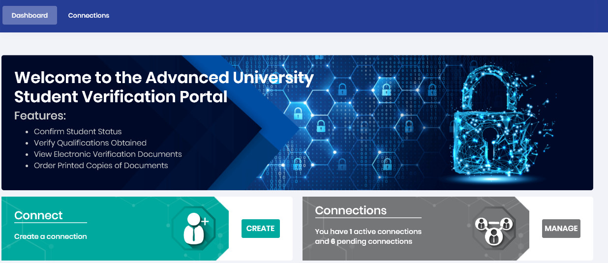
Students registered on the University Portal can send connection requests via email to allow 3rd Parties to view electronic representations of their qualification certificates.
On receipt of such a request, the 3rd party carries out a very simple registration process which will then provide them with secure access to the certificates in question. For added security there is also an email verification procedure to ensure your email address is valid.
- The connection, once created, can be cancelled by either party at any time.
- The connection has a default expiry time but can be extended by the student.
- The 3rd Party may also request an extension if required.
- Once registered, a 3rd party can then send connection requests to other students in the University using the students email address.

3. Useful links
On the home page, there are several useful links including About, Privacy, FAQ, Cookies, Terms and Support, all on the bottom right of the page.

4. Registration
This is a very quick and simple registration process requiring only your email address, password creation and name.

5. Login
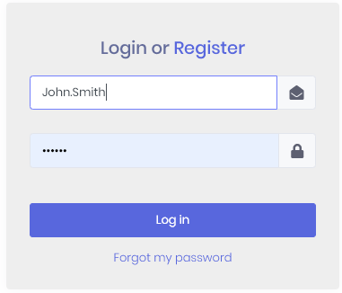
- Username – this is your email address.
- Email address – This can be changed from within your profile.
- Password – This can be changed from within your profile.
- Locked out – If you become locked out you can either wait until the system automatically unlocks you (this is configurable and varies between universities) or contact support using the details provided in the support link.

6. Forgotten password
If you have forgotten your password you will be able to recover from this by using the Forgotten Password procedure.

7. Dashboard
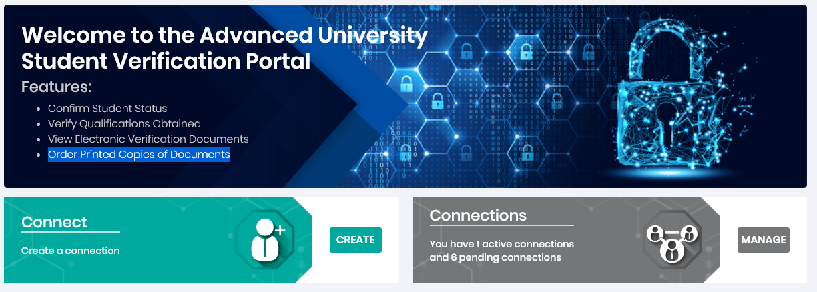
- Connect (Create)
  - Once registered, 3rd Parties can then request access to others students’ qualifications. To do this you simply require to know the student's name and email address. If the student in question is already registered on the portal and accepts the connection then the 3rd party will be able to view their documents straight away. If the student has not yet registered on the portal, then the student will have to carry out the registration process before the connection can be achieved.
- Connections (Manage)
- Allows the 3rd party to manage their existing connections with students.
- View – Allows the viewing of PDF electronic versions of the available certificates.
You will notice when you view a document that there is a barcode present on the bottom of the page. This can be scanned using a barcode scanning app on your mobile phone which will take you to the Certificate verification website. Here your document will verified as to whether on not it is an actual qualification certificate issued by the University.
- Extend – An extension of the expiry date for the connection can be requested here, the student will have to first approve the request.
- Cancel – The connection can be cancelled by the 3rd party at any time.

8. Profiles
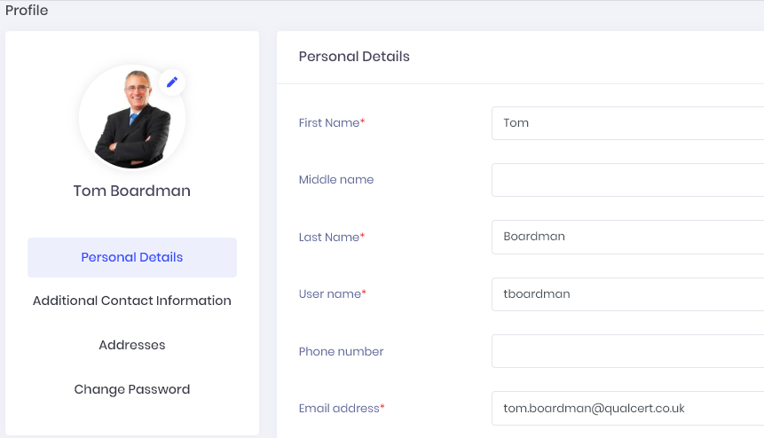
Each user has a personal profile which can detail the following items of information which will then be visible to any student that has a connection with you.
- Photo – Upload a photo by browsing to image files on your PC.
- Personal details
- Additional Contact information
- Phone numbers
- Email addresses
- Social media
- Addresses
- Change password

9. Logout
Logout by using the logout button which is found by clicking on your name or profile photo (Initials - if no photo is uploaded) at the top right of the web page.

